BSAN 450 Assignment 8

1) In this problem the data is chemical concentration readings over consecutive periods. The data is in a file named ChemicalConcentration.csv. The name of the variable in this file is Con.

a) Read this data into R Studio. Plot a time series plot of this data. Does this data appear to be a stationary time series? Justify your answer.

**Yes this data does looks like it is a stationary time series. The variance of the wave looks to be consistent, and it looks like it is osiliating around one value.**

b) Plot the sample autocorrelations and the sample partial autocorrelations for this data. From these plots identify a model that would be appropriate for this data. Justify your choice.

The R commands to do parts a and b follow.

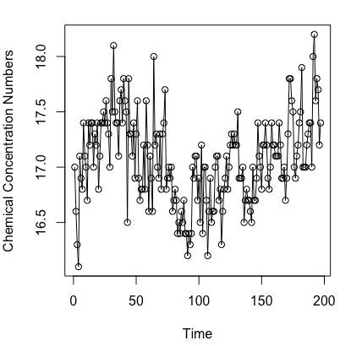

**An AR(2) model would be the best because there are two lags in the Partial ACF before the data tampers off.**

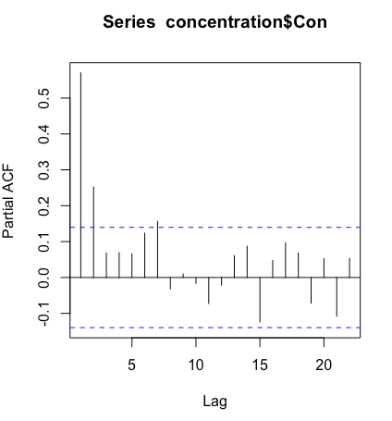 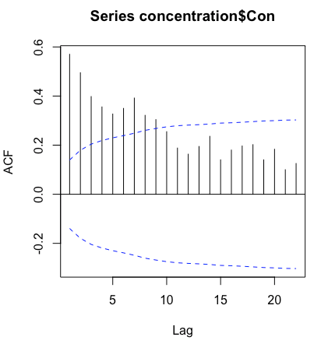

c) Assume that this data follows an AR(2) model. Estimate the parameters in this model. Are all the parameters in this model statistically significantly different from zero? Perform the diagnostic checks for this model. Are there any problems suggested?

The R commands to do this part follow.

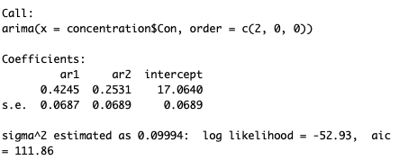

**The parameters in this model are statistically significant from zero because for ar1 the confidence interval is (.3558, .4932) and the ar2 confidence interval is (.1842, .3220)**

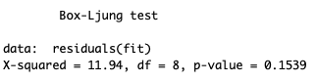

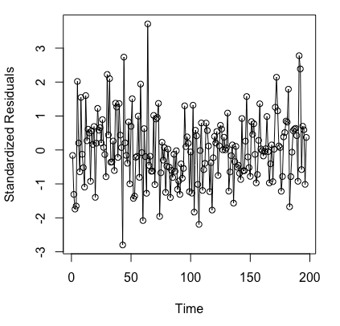 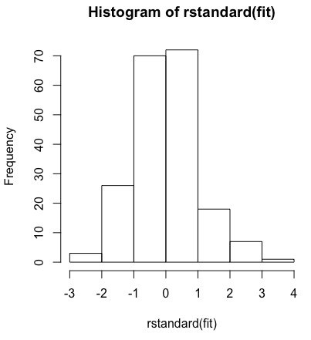

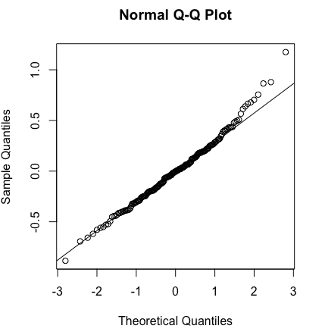 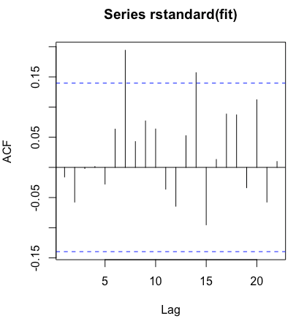

**There seems to be a couple outliers, but other than that the dianogstics for this model do not indicate any problems.**

d) As part of checking the model estimate the following more general models. (i) An ARMA(2,1) model

(ii) An ARMA(3, 0) model. Interpret the results. What do these suggest about the best model for this data?

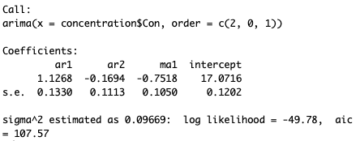

**For ARMA(2,1) the interval confidence includes zero thus indicating that the parameter is not statistically significant difference from zero.**

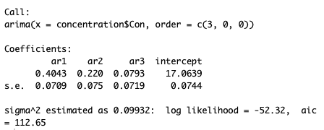

**For ARMA(3, 0) the interval confidence is close to zero, but not zero so it is statistically different from zero, but the AR(2) model is the best fit out of all three models.**

e) Compute and plot forecasts for the model you believe is most appropriate.

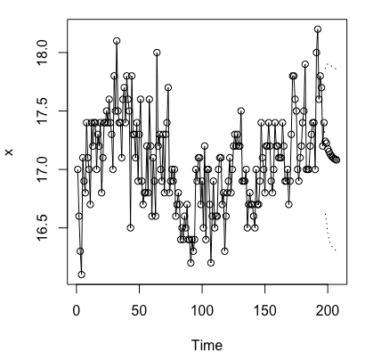 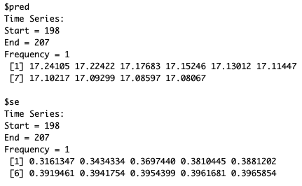

2) The data for this example is percent of the time that parts for industrial project available when needed for a sequence of weeks. The data is in a file named “time.csv” and the name of the time series in that file is “Time”.

a) Read the data into R Studio. Plot a time series plot of the data, plot the sample ACF, and plot the sample PACF for this data. Use the following R commands. Based on this output suggest a model that would be appropriate for this time series.

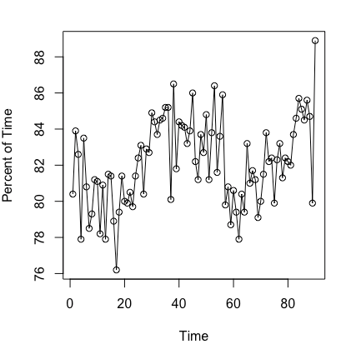 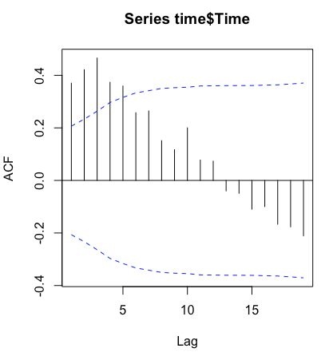 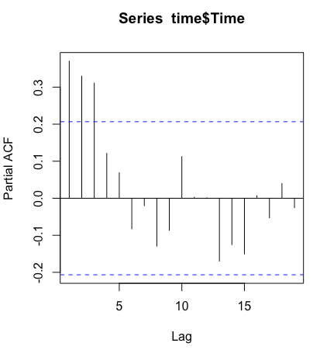

**An appropriate time model would be ARMA(1,1) because both of the graphs indicate that as the lag increases the values are decrementing.**

b) Fit the model that you identified in part a). Perform the diagnostic checks for this model. Note that the first command is appropriate if you want to fit an ARMA(1,1) model in R. The expression order = c(1,0,1) tells R the model to fit. The first element is c() is the AR order, the second element is something that we will see later (for now this should be 0), and the third element is the MA order of the model. Thus if you want to fit an AR(2) model the expression should be order = c(2,0,0). If you want to fit an MA(2) model the expression should be order = c(0,0,2).

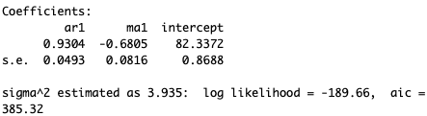

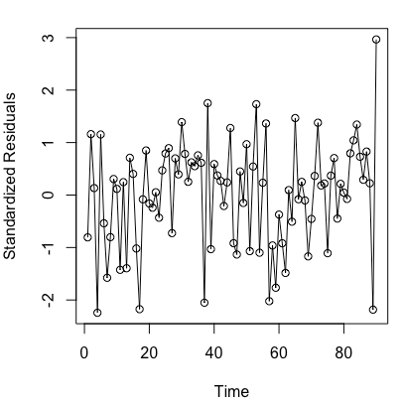 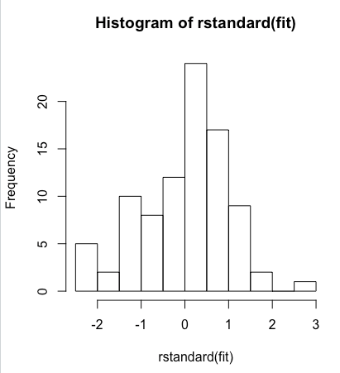

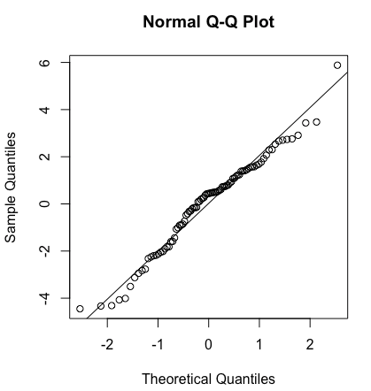 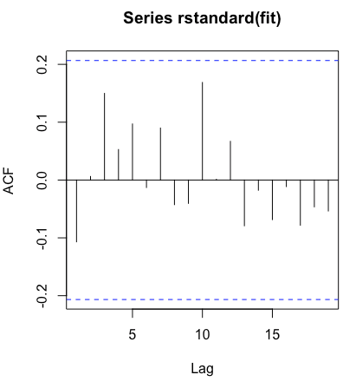

**The QQ-Norm plot is slightly less than optimal, but overall does not indicate an issue. All other diagnostics indicate no issue. The models also indicate that the parameter is statistically different from zero.**

c) Perform the Box-Ljung test on the residuals. The command to do this for an ARMA(1,1) model is given below. The expression lag=10 tells R to use the first 10 autocorrelations in the test. This is a good choice for the models we are currently using in the class. In the expression fitdf=2, the value 2 needs to be set to be the number of AR parameters plus the number of MA parameters in the model you fit. Thus if you fit an ARMA(1,1) model, fitdf=2 because there are 2 AR plus MA parameters. If you fit an AR(1) model the fitdf=1 is appropriate because there is 1 AR parameter.

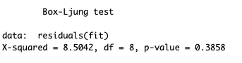

d) Do the residual plots suggest that there is anything wrong with the model you fit? Why or why not?

When you get a model you believe is appropriate for this data, forecast the next 10 values of this time series and plot the forecasts as you did in problem 1.

**The residuals do not suggest that there is anything wrong with the model. The variance looks approximately the same and the values do not appear to be increasing or decreasing.**

